Practicum Case | 
MATH6183 | MATH6183001 | MATH6183016 | MATH6183049
Scientific Computing
Mathematics & Statistics | E231-MATH6183-JJ01-03
Valid on Even Semester Year 2022/2023 | Revision 00

Learning Outcomes
- LO2 – solve the systems of linear algebraic equations, eigenvalues, eigenvectors, regression and interpolation through scientific computation

Topic
- Session 03 – Regression & Interpolation

Sub Topics
- Plotting Using Matplotlib Library
- Least Square Regression
- Linear Interpolation
- Cubic Interpolation
- Newton Polynomial Interpolation

Soal
Case

- Least Square Regression
Create a Least Square Regression from the matrix (x, y) in “matrix-1.txt”, then print the value of ‘m’ and ‘c’ from the formula of “y = mx + c”. Lastly, show the original matrix and the result of Least Square Regression in one plot using matplotlib (with legend).
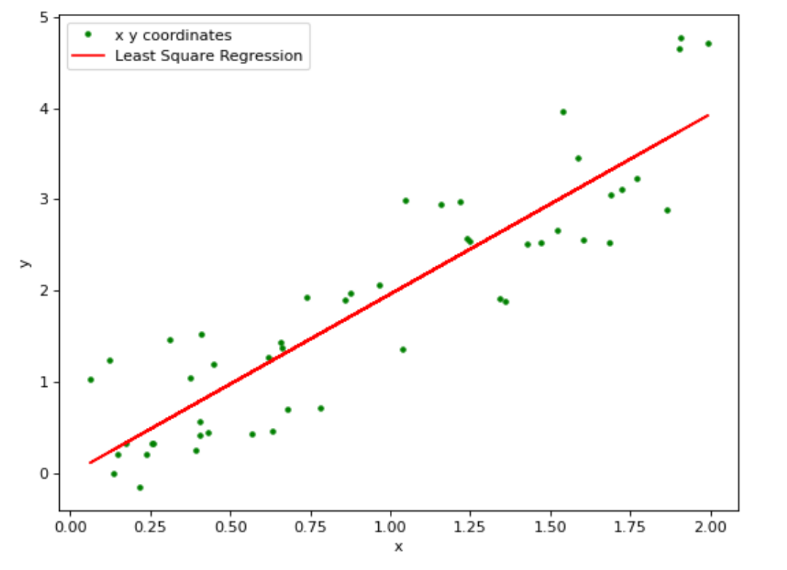
Figure 1. Least Square Regression
- Polynomial Regression
Create a Polynomial Regression with 7 order from the matrix (x, y) in “matrix-2.txt”, then show the result of Polynomial Regression in each order plot using matplotlib.
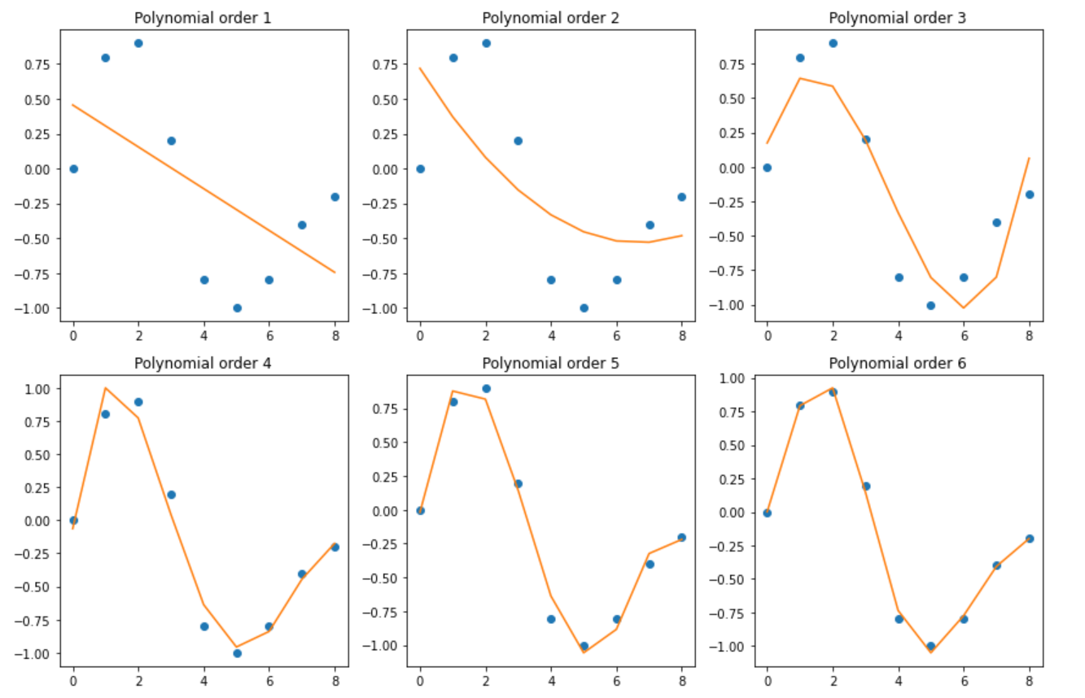
Figure 2. Polynomial Regression

